Cost Management plan

Made by: Hazem Hamada Abdellatif, 16p3100.

***Units of measure:***

Effort is measured in person hour.

Money is measured in dollars.

Time is measured in days.

***Levels of accuracy:***

Any calculations will be up to 2 decimal places or in money will be to the nearest 100$. Cost estimating will be only on two levels in the WBS.

***Control thresholds:***

Control threshold in this project is 10000$, as if we are behind the schedule by 10000$, we need to take corrective actions.

***Rules of performance measurement:***

in this project the cost performance measurement would be by EVM.

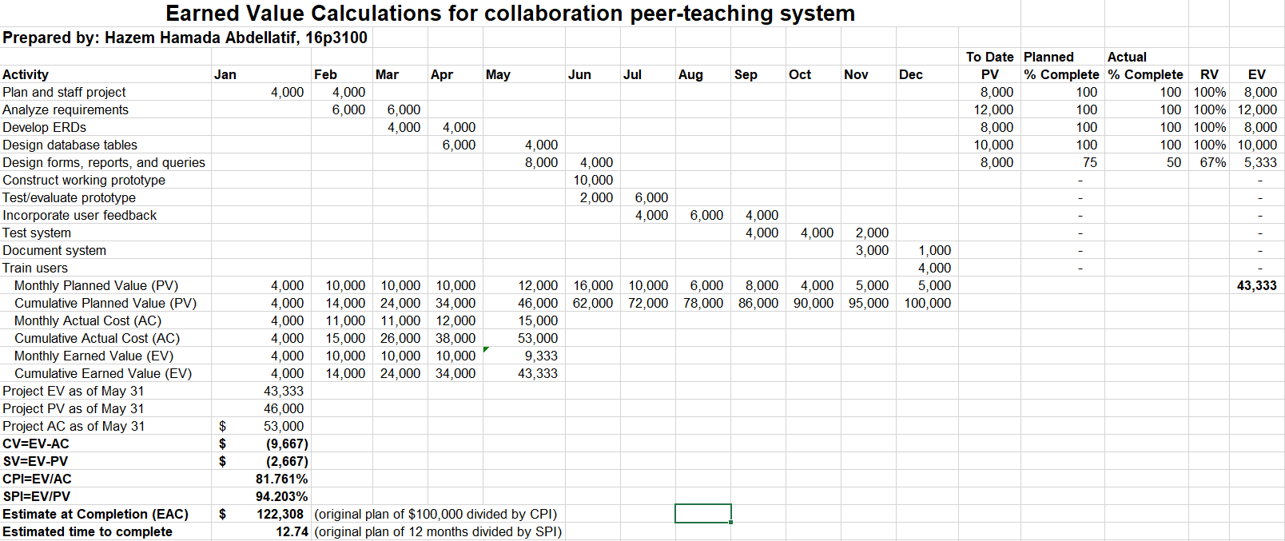

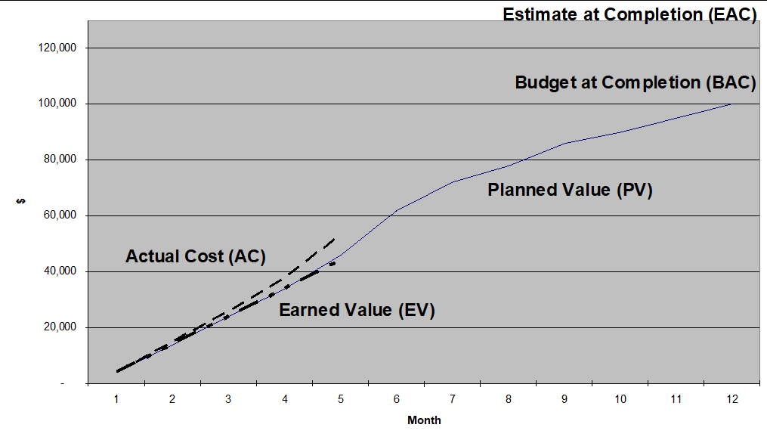

***Organizational procedures links:***

Controls accounts:

1. Creating budget and cost estimate: budget and cost estimate must be supervised by the organization head manager. The software cost estimation is by the algorithmic methods to increase its accuracy.
2. Purchasing tools: purchasing the tools or any resources must be done after referring to the plan and taking the acceptance of the stakeholders and the project manager.
3. Controlling changes: if any changes are done to the project that may affects the budget it must be reviewed by the stakeholders and take there acceptance.

***Reporting formats:***

Every team leader or manager must report periodically to the project manager the process and the work done and any changes needed to be done. The reporting must be done weekly for the project manager, a brief high-level cost report to senior management in every 2 weeks, and a detailed report in every month. The reporting would be done via email or formal hardcopy reports.

***Process description:***

The process of performing the cost management plane is by reporting periodically to the manager he would analyze the current state and conditions for taking the decisions and making changes. The cost schedule would be applied and after any step a report must be made to decide if any changes have to be made. After any purchase the project cost estimate and budget must be reviewed to analyze the situation and see if we are on the plane or there is something wronge.